**A Reasearch on the Relationship between Sleeping time and Concentration in class**

Yuchao Huang(Tony), Yushun Chen(Jerry)

G11 AP Statistics

*Beijing National Day School, Beijing China*

1. **Introduction**

According to the Sleep Foudation(A OneCare Media Company), sleep is essential for teenagers because it plays an important role in their physical and mental development. Most teenagers should get hours of sleep between 8 and 10. However due to the academy stress and diversification of social platform, many teens get far less sleep than they need. Most students need to stay up late to finish their studies that day. Most of them go to bed after 12 o 'clock and get up very early. Due to the lack of rest time, most students will show lack of concentration and fatigue in class in the next few days. Considering that each student is an individual, each person has a different constitution. Some students feel extremely excited the next day after staying up late, while others feel sleepy soon after. This experiment will investigate the relationship between students' sleep time and their concentration in class the next day.

1. **Background Reasearch**

This experiment is to explore the relationship between independent variable and dependent variable. The independent variable, which is the sleeping time, Sleep duration is only a small subset of how rested you are, as measures of sleep quality and physical activity need to be taken into account. A long time of classroom study will increase the burden on people's body and brain, so people need enough sleep to recover their physical and mental state. Because of circadian and individual differences, some early risers are more likely to stay focused in the morning, while late sleepers are better suited to study at night. To quantify this, we turned to the ESS Sleep Data Quality Analysis to determine whether sleep duration affected people's mental state the next day.

1. **Methods and Procedures**

According to ESS, we designed the questionnaire to fill in the time you lost sleep last night and how tired you are likely to be doing things today. In the questionnaire, each option of each question has a corresponding score. We will sum the scores of each question to get a final score, and record the number of scores in each sleeping period.

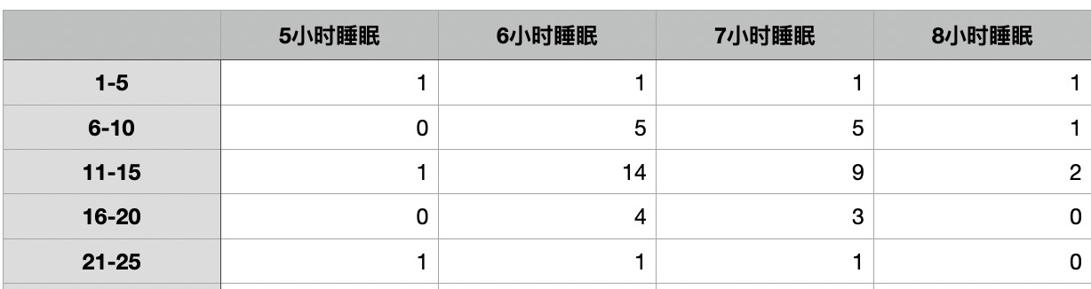

1. **Result**
2. **Problems in the project**

From the point of view of collecting data, students who fill out questionnaires may be biased, because they may exaggerate or underestimate whether they feel tired or not. Secondly, although the questions in the questionnaire are based on scientific research, they are still answered through the subjective judgment of the fillers, so the accuracy cannot be guaranteed.

1. **Conclusion**